**Application : 1**

AIM :

Design and develop an android app for greeting user by their name.

Objectives

To familiarise simple android application

Apparatus/Tools/Equipments/Components

Android studio

Procedure

1. In Android Studio, create a new project.

2. Give the name to the Application and choose the project location and minimum android sdk version to marshmallow.

3. Select empty activity for development of android application.

4. Design UI for the application

5. Implement the java code for the application.

6. Open AVD manager and Run virtual device.

7. Run project on virtual device.

MainActivity.java

package com.example.ishank.helloworldapp;

import android.support.v7.app.AppCompatActivity;

import android.os.Bundle;

import android.widget.EditText;

import android.widget.TextView;

import android.view.View;

public class MainActivity extends AppCompatActivity {

@Override

protected void onCreate(Bundle savedInstanceState) {

super.onCreate(savedInstanceState);

setContentView(R.layout.activity_main);

}

public void show(View v){

EditText et=findViewById(R.id.editText3);

String name;

name=et.getText().toString();

TextView tv=findViewById(R.id.textView);

name="Hello "+name;

tv.setText(name);

}

}

Layout_main.xml

<?xml version="1.0" encoding="utf-8"?>

<android.support.constraint.ConstraintLayout xmlns:android="http://schemas.android.com/apk/res/android"

xmlns:app="http://schemas.android.com/apk/res-auto"

xmlns:tools="http://schemas.android.com/tools"

android:layout_width="match_parent"

android:layout_height="match_parent"

tools:context=".MainActivity"

tools:layout_editor_absoluteY="25dp">

<EditText

android:id="@+id/editText3"

android:layout_width="wrap_content"

android:layout_height="wrap_content"

android:layout_marginBottom="16dp"

android:layout_marginEnd="16dp"

android:layout_marginLeft="16dp"

android:layout_marginRight="16dp"

android:layout_marginStart="16dp"

android:layout_marginTop="16dp"

android:ems="10"

android:hint="@string/enter_your_name"

android:inputType="textPersonName"

app:layout_constraintBottom_toBottomOf="parent"

app:layout_constraintEnd_toEndOf="parent"

app:layout_constraintHorizontal_bias="0.503"

app:layout_constraintStart_toStartOf="parent"

app:layout_constraintTop_toTopOf="parent"

app:layout_constraintVertical_bias="0.085" />

<Button

android:id="@+id/button"

android:layout_width="wrap_content"

android:layout_height="49dp"

android:layout_marginBottom="16dp"

android:layout_marginEnd="16dp"

android:layout_marginLeft="16dp"

android:layout_marginRight="16dp"

android:layout_marginStart="16dp"

android:layout_marginTop="16dp"

android:onClick="show"

android:text="@string/click"

android:textStyle="bold"

app:layout_constraintBottom_toBottomOf="parent"

app:layout_constraintEnd_toEndOf="parent"

app:layout_constraintStart_toStartOf="parent"

app:layout_constraintTop_toBottomOf="@+id/editText3"

app:layout_constraintVertical_bias="0.129" />

<TextView

android:id="@+id/textView"

android:layout_width="263dp"

android:layout_height="69dp"

android:layout_marginBottom="16dp"

android:layout_marginEnd="16dp"

android:layout_marginLeft="16dp"

android:layout_marginRight="16dp"

android:layout_marginStart="16dp"

android:layout_marginTop="16dp"

android:gravity="center_vertical"

android:textStyle="bold"

app:layout_constraintBottom_toBottomOf="parent"

app:layout_constraintEnd_toEndOf="parent"

app:layout_constraintHorizontal_bias="0.505"

app:layout_constraintStart_toStartOf="parent"

app:layout_constraintTop_toBottomOf="@+id/button"

app:layout_constraintVertical_bias="0.334" />

</android.support.constraint.ConstraintLayout>

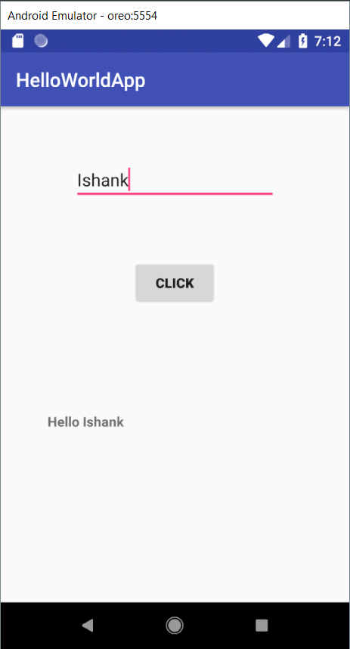

**Application : 2**

AIM :

Create an android application to check eligibility for casting vote.

Objectives

To use conditional statements in Java file.

Apparatus/Tools/Equipments/Components

Android studio

Procedure

1. In Android Studio, create a new project.

2. Give the name to the Application and choose the project location and minimum android sdk version to marshmallow.

3. Select empty activity for development of android application.

4. Design UI for the application

5. Implement the java code for the application.

6. Open AVD manager and Run virtual device.

7. Run project on virtual device.

MainActivity.java

package com.example.ishank.helloworldapp;

import android.support.v7.app.AppCompatActivity;

import android.os.Bundle;

import android.widget.EditText;

import android.widget.TextView;

import android.view.View;

public class MainActivity extends AppCompatActivity {

@Override

protected void onCreate(Bundle savedInstanceState) {

super.onCreate(savedInstanceState);

setContentView(R.layout.activity_main);

}

public void check(View v){

EditText et=findViewById(R.id.editText4);

TextView tv=findViewById(R.id.textView2);

int age;

age=Integer.parseInt(et.getText().toString());

if(age>=18)

tv.setText("You are eligible to vote");

else

tv.setText("You are not eligible to vote");

}

}

Acivity_main.xml

<?xml version="1.0" encoding="utf-8"?>

<android.support.constraint.ConstraintLayout xmlns:android="http://schemas.android.com/apk/res/android"

xmlns:app="http://schemas.android.com/apk/res-auto"

xmlns:tools="http://schemas.android.com/tools"

android:layout_width="match_parent"

android:layout_height="match_parent"

tools:context=".MainActivity"

tools:layout_editor_absoluteY="25dp">

<EditText

android:id="@+id/editText4"

android:layout_width="217dp"

android:layout_height="wrap_content"

android:layout_marginBottom="16dp"

android:layout_marginEnd="16dp"

android:layout_marginLeft="16dp"

android:layout_marginRight="16dp"

android:layout_marginStart="16dp"

android:layout_marginTop="16dp"

android:ems="10"

android:hint="@string/enter_your_age"

android:inputType="number"

app:layout_constraintBottom_toBottomOf="parent"

app:layout_constraintEnd_toEndOf="parent"

app:layout_constraintHorizontal_bias="0.503"

app:layout_constraintStart_toStartOf="parent"

app:layout_constraintTop_toTopOf="parent"

app:layout_constraintVertical_bias="0.078" />

<Button

android:id="@+id/button3"

android:layout_width="wrap_content"

android:layout_height="wrap_content"

android:layout_marginBottom="16dp"

android:layout_marginEnd="16dp"

android:layout_marginLeft="16dp"

android:layout_marginRight="16dp"

android:layout_marginStart="16dp"

android:layout_marginTop="16dp"

android:onClick="check"

android:text="Check"

app:layout_constraintBottom_toBottomOf="parent"

app:layout_constraintEnd_toEndOf="parent"

app:layout_constraintStart_toStartOf="parent"

app:layout_constraintTop_toBottomOf="@+id/editText4"

app:layout_constraintVertical_bias="0.179"

tools:text="Check" />

<TextView

android:id="@+id/textView2"

android:layout_width="242dp"

android:layout_height="73dp"

android:layout_marginBottom="16dp"

android:layout_marginEnd="16dp"

android:layout_marginLeft="16dp"

android:layout_marginRight="16dp"

android:layout_marginStart="16dp"

android:layout_marginTop="16dp"

android:gravity="center_vertical"

app:layout_constraintBottom_toBottomOf="parent"

app:layout_constraintEnd_toEndOf="parent"

app:layout_constraintStart_toStartOf="parent"

app:layout_constraintTop_toBottomOf="@+id/button3"

app:layout_constraintVertical_bias="0.408" />

</android.support.constraint.ConstraintLayout>

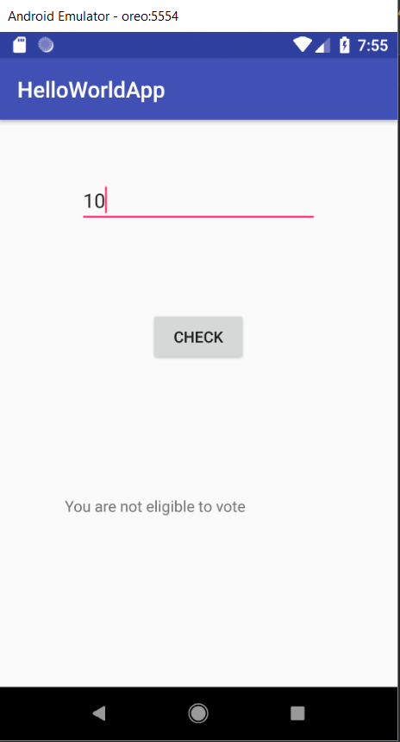.

**Application : 3**

AIM :

Design and develop an android application to swap the contents of two EditText.

Objectives

To get familiar with different android widgets.

Apparatus/Tools/Equipments/Components

Android studio

Procedure

1. In Android Studio, create a new project.

2. Give the name to the Application and choose the project location and minimum android sdk version to marshmallow.

3. Select empty activity for development of android application.

4. Design UI for the application

5. Implement the java code for the application.

6. Open AVD manager and Run virtual device.

7. Run project on virtual device.

MainActivity.java

package com.example.ishank.helloworldapp;

import android.support.v7.app.AppCompatActivity;

import android.os.Bundle;

import android.widget.EditText;

import android.widget.TextView;

import android.view.View;

public class MainActivity extends AppCompatActivity {

@Override

protected void onCreate(Bundle savedInstanceState) {

super.onCreate(savedInstanceState);

setContentView(R.layout.activity_main);

}

public void swap(View v){

EditText et,et2;

et=findViewById(R.id.editText5);

et2=findViewById(R.id.editText6);

String first,second;

first=et.getText().toString();

second=et2.getText().toString();

et.setText(second);

et2.setText(first);

}

}

Activity_main.xml

<?xml version="1.0" encoding="utf-8"?>

<android.support.constraint.ConstraintLayout xmlns:android="http://schemas.android.com/apk/res/android"

xmlns:app="http://schemas.android.com/apk/res-auto"

xmlns:tools="http://schemas.android.com/tools"

android:layout_width="match_parent"

android:layout_height="match_parent"

tools:context=".MainActivity"

tools:layout_editor_absoluteY="25dp">

<EditText

android:id="@+id/editText5"

android:layout_width="wrap_content"

android:layout_height="wrap_content"

android:layout_marginBottom="16dp"

android:layout_marginEnd="16dp"

android:layout_marginLeft="16dp"

android:layout_marginRight="16dp"

android:layout_marginStart="16dp"

android:layout_marginTop="16dp"

android:ems="10"

android:hint="Enter first string"

android:inputType="textPersonName"

app:layout_constraintBottom_toBottomOf="parent"

app:layout_constraintEnd_toEndOf="parent"

app:layout_constraintHorizontal_bias="0.503"

app:layout_constraintStart_toStartOf="parent"

app:layout_constraintTop_toTopOf="parent"

app:layout_constraintVertical_bias="0.083" />

<EditText

android:id="@+id/editText6"

android:layout_width="wrap_content"

android:layout_height="wrap_content"

android:layout_marginBottom="16dp"

android:layout_marginEnd="16dp"

android:layout_marginLeft="16dp"

android:layout_marginRight="16dp"

android:layout_marginStart="16dp"

android:layout_marginTop="16dp"

android:ems="10"

android:hint="Enter second string"

android:inputType="textPersonName"

app:layout_constraintBottom_toBottomOf="parent"

app:layout_constraintEnd_toEndOf="parent"

app:layout_constraintHorizontal_bias="0.503"

app:layout_constraintStart_toStartOf="parent"

app:layout_constraintTop_toBottomOf="@+id/editText5"

app:layout_constraintVertical_bias="0.17" />

<Button

android:id="@+id/button4"

android:layout_width="wrap_content"

android:layout_height="wrap_content"

android:layout_marginBottom="16dp"

android:layout_marginEnd="16dp"

android:layout_marginLeft="16dp"

android:layout_marginRight="16dp"

android:layout_marginStart="16dp"

android:layout_marginTop="16dp"

android:onClick="swap"

android:text="SWAP"

app:layout_constraintBottom_toBottomOf="parent"

app:layout_constraintEnd_toEndOf="parent"

app:layout_constraintStart_toStartOf="parent"

app:layout_constraintTop_toBottomOf="@+id/editText6"

app:layout_constraintVertical_bias="0.252" />

</android.support.constraint.ConstraintLayout>

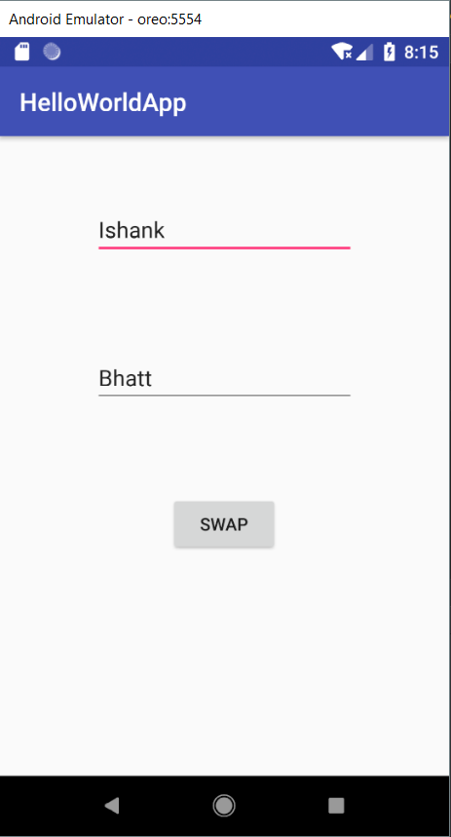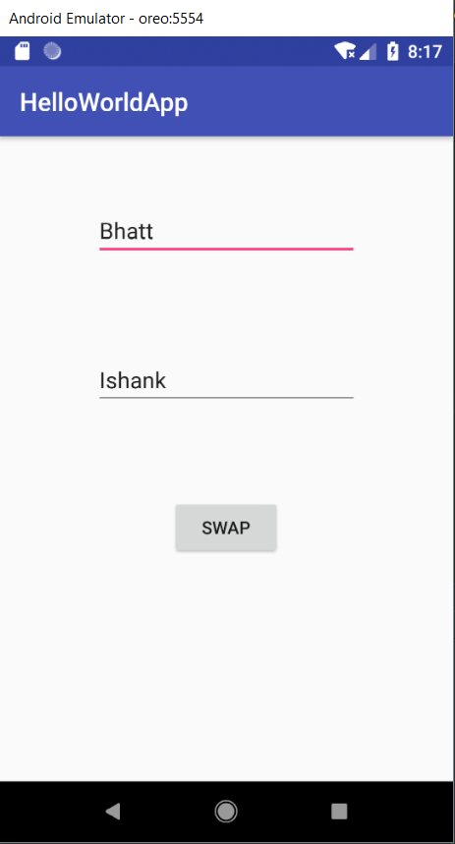

**Application : 4**

AIM :

Develop an android application to convert CGPA to percentage and vice versa. Objectives

To get familiar with buttons calling different methods.

Apparatus/Tools/Equipments/Components

Android studio

Procedure

1. In Android Studio, create a new project.

2. Give the name to the Application and choose the project location and minimum android sdk version to marshmallow.

3. Select empty activity for development of android application.

4. Design UI for the application

5. Implement the java code for the application.

6. Open AVD manager and Run virtual device.

7. Run project on virtual device.

MainActivity.java

package com.example.ishank.helloworldapp;

import android.support.v7.app.AppCompatActivity;

import android.os.Bundle;

import android.widget.EditText;

import android.widget.TextView;

import android.view.View;

public class MainActivity extends AppCompatActivity {

@Override

protected void onCreate(Bundle savedInstanceState) {

super.onCreate(savedInstanceState);

setContentView(R.layout.activity_main);

}

public void convert(View v){

EditText et=findViewById(R.id.editText);

float num,res,mul=9.5f;

TextView tv=findViewById(R.id.textView);

num=Float.parseFloat(et.getText().toString());

if(num<=10) {

res = num*mul;

tv.setText(String.valueOf(res+"%"));

}

else

{

res = num/mul;

tv.setText(String.valueOf(res));

}

}

}

Activity_main.xml

<?xml version="1.0" encoding="utf-8"?>

<android.support.constraint.ConstraintLayout xmlns:android="http://schemas.android.com/apk/res/android"

xmlns:app="http://schemas.android.com/apk/res-auto"

xmlns:tools="http://schemas.android.com/tools"

android:layout_width="match_parent"

android:layout_height="match_parent"

tools:context=".MainActivity"

tools:layout_editor_absoluteY="25dp">

<EditText

android:id="@+id/editText"

android:layout_width="wrap_content"

android:layout_height="wrap_content"

android:layout_marginBottom="16dp"

android:layout_marginEnd="16dp"

android:layout_marginLeft="16dp"

android:layout_marginRight="16dp"

android:layout_marginStart="16dp"

android:layout_marginTop="16dp"

android:ems="10"

android:hint="@string/enter_cgpa_percentage"

android:inputType="numberDecimal"

app:layout_constraintBottom_toBottomOf="parent"

app:layout_constraintEnd_toEndOf="parent"

app:layout_constraintHorizontal_bias="0.503"

app:layout_constraintStart_toStartOf="parent"

app:layout_constraintTop_toTopOf="parent"

app:layout_constraintVertical_bias="0.094" />

<Button

android:id="@+id/button"

android:layout_width="wrap_content"

android:layout_height="wrap_content"

android:layout_marginBottom="16dp"

android:layout_marginEnd="16dp"

android:layout_marginLeft="16dp"

android:layout_marginRight="16dp"

android:layout_marginStart="16dp"

android:layout_marginTop="16dp"

android:onClick="convert"

android:text="@string/convert"

app:layout_constraintBottom_toBottomOf="parent"

app:layout_constraintEnd_toEndOf="parent"

app:layout_constraintStart_toStartOf="parent"

app:layout_constraintTop_toBottomOf="@+id/editText"

app:layout_constraintVertical_bias="0.146" />

<TextView

android:id="@+id/textView"

android:layout_width="256dp"

android:layout_height="65dp"

android:layout_marginBottom="16dp"

android:layout_marginEnd="16dp"

android:layout_marginLeft="16dp"

android:layout_marginRight="16dp"

android:layout_marginStart="16dp"

android:layout_marginTop="16dp"

android:gravity="center_horizontal"

android:textSize="18sp"

android:textStyle="bold"

app:layout_constraintBottom_toBottomOf="parent"

app:layout_constraintEnd_toEndOf="parent"

app:layout_constraintStart_toStartOf="parent"

app:layout_constraintTop_toBottomOf="@+id/button"

app:layout_constraintVertical_bias="0.36" />

</android.support.constraint.ConstraintLayout>

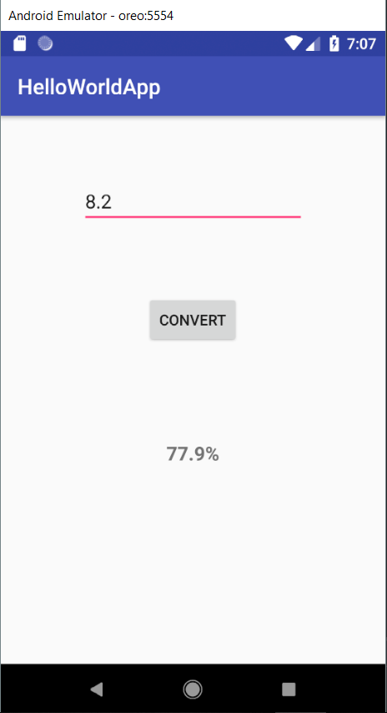

**Application : 5**

AIM :

Create an android application to convert dollar into rupees and vice versa.

Objectives

To get familiar with buttons calling different methods.

Apparatus/Tools/Equipments/Components

Android studio

Procedure

1. In Android Studio, create a new project.

2. Give the name to the Application and choose the project location and minimum android sdk version to marshmallow.

3. Select empty activity for development of android application.

4. Design UI for the application

5. Implement the java code for the application.

6. Open AVD manager and Run virtual device.

7. Run project on virtual device.

MainActivity.java

package com.example.ishank.helloworldapp;

import android.support.v7.app.AppCompatActivity;

import android.os.Bundle;

import android.widget.EditText;

import android.widget.TextView;

import android.view.View;

public class MainActivity extends AppCompatActivity {

@Override

protected void onCreate(Bundle savedInstanceState) {

super.onCreate(savedInstanceState);

setContentView(R.layout.activity_main);

}

public void convert(View v) {

float usd,inr;

if(v.getId()==R.id.button2){

EditText et,et2;

et=findViewById(R.id.editText2);

et2=findViewById(R.id.editText3);

usd=Float.parseFloat(et.getText().toString());

inr=usd*71.613f;

et2.setText(String.valueOf(inr));

}

else{

EditText et,et2;

et2=findViewById(R.id.editText5);

et=findViewById(R.id.editText4);

inr=Float.parseFloat(et.getText().toString());

usd=inr*0.01396f;

et2.setText(String.valueOf(usd));

}

}

}

Activity_main.xml

<?xml version="1.0" encoding="utf-8"?>

<android.support.constraint.ConstraintLayout xmlns:android="http://schemas.android.com/apk/res/android"

xmlns:app="http://schemas.android.com/apk/res-auto"

xmlns:tools="http://schemas.android.com/tools"

android:layout_width="match_parent"

android:layout_height="match_parent"

tools:context=".MainActivity"

tools:layout_editor_absoluteY="25dp">

<EditText

android:id="@+id/editText2"

android:layout_width="94dp"

android:layout_height="44dp"

android:layout_marginBottom="16dp"

android:layout_marginLeft="16dp"

android:layout_marginStart="16dp"

android:layout_marginTop="16dp"

android:ems="10"

android:hint="USD"

android:inputType="textPersonName"

app:layout_constraintBottom_toBottomOf="parent"

app:layout_constraintStart_toStartOf="parent"

app:layout_constraintTop_toTopOf="parent"

app:layout_constraintVertical_bias="0.181" />

<EditText

android:id="@+id/editText3"

android:layout_width="96dp"

android:layout_height="wrap_content"

android:layout_marginEnd="16dp"

android:layout_marginLeft="16dp"

android:layout_marginRight="16dp"

android:layout_marginStart="16dp"

android:ems="10"

android:hint="INR"

android:inputType="textPersonName"

app:layout_constraintBaseline_toBaselineOf="@+id/button2"

app:layout_constraintEnd_toEndOf="parent"

app:layout_constraintHorizontal_bias="0.617"

app:layout_constraintStart_toEndOf="@+id/button2" />

<Button

android:id="@+id/button2"

android:layout_width="wrap_content"

android:layout_height="wrap_content"

android:layout_marginLeft="44dp"

android:layout_marginStart="44dp"

android:onClick="convert"

android:text="To"

app:layout_constraintBaseline_toBaselineOf="@+id/editText2"

app:layout_constraintStart_toEndOf="@+id/editText2" />

<TextView

android:id="@+id/textView2"

android:layout_width="140dp"

android:layout_height="36dp"

android:layout_marginBottom="16dp"

android:layout_marginEnd="16dp"

android:layout_marginLeft="16dp"

android:layout_marginRight="16dp"

android:layout_marginStart="16dp"

android:layout_marginTop="16dp"

android:gravity="center_vertical"

android:text="USD to INR"

android:textSize="18sp"

app:layout_constraintBottom_toTopOf="@+id/editText2"

app:layout_constraintEnd_toEndOf="parent"

app:layout_constraintHorizontal_bias="0.566"

app:layout_constraintStart_toStartOf="parent"

app:layout_constraintTop_toTopOf="parent"

app:layout_constraintVertical_bias="0.468" />

<TextView

android:id="@+id/textView3"

android:layout_width="145dp"

android:layout_height="42dp"

android:layout_marginBottom="16dp"

android:layout_marginEnd="16dp"

android:layout_marginLeft="16dp"

android:layout_marginRight="16dp"

android:layout_marginStart="16dp"

android:layout_marginTop="16dp"

android:text="INR to USD"

android:gravity="fill_horizontal"

android:textSize="18sp"

android:textStyle="bold"

app:layout_constraintBottom_toBottomOf="parent"

app:layout_constraintEnd_toEndOf="parent"

app:layout_constraintHorizontal_bias="0.57"

app:layout_constraintStart_toStartOf="parent"

app:layout_constraintTop_toTopOf="parent"

app:layout_constraintVertical_bias="0.446" />

<EditText

android:id="@+id/editText4"

android:layout_width="98dp"

android:layout_height="44dp"

android:layout_marginBottom="16dp"

android:layout_marginLeft="16dp"

android:layout_marginStart="16dp"

android:layout_marginTop="52dp"

android:ems="10"

android:hint="INR"

android:inputType="textPersonName"

app:layout_constraintBottom_toBottomOf="parent"

app:layout_constraintStart_toStartOf="parent"

app:layout_constraintTop_toBottomOf="@+id/textView3"

app:layout_constraintVertical_bias="0.0" />

<Button

android:id="@+id/button3"

android:layout_width="87dp"

android:layout_height="wrap_content"

android:layout_marginLeft="32dp"

android:layout_marginStart="32dp"

android:onClick="convert"

android:text="To"

app:layout_constraintBaseline_toBaselineOf="@+id/editText4"

app:layout_constraintStart_toEndOf="@+id/editText4" />

<EditText

android:id="@+id/editText5"

android:layout_width="80dp"

android:layout_height="48dp"

android:layout_marginEnd="16dp"

android:layout_marginLeft="16dp"

android:layout_marginRight="16dp"

android:layout_marginStart="16dp"

android:ems="10"

android:hint="USD"

android:inputType="textPersonName"

app:layout_constraintBaseline_toBaselineOf="@+id/button3"

app:layout_constraintEnd_toEndOf="parent"

app:layout_constraintStart_toEndOf="@+id/button3" />

</android.support.constraint.ConstraintLayout>

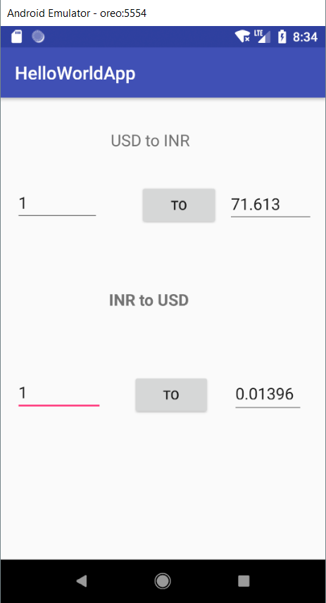

**Application : 6**

AIM :

Design and develop an android application BMI calculator.

Objectives

To get familiar with buttons calling different methods.

Apparatus/Tools/Equipments/Components

Android studio

Procedure

1. In Android Studio, create a new project.

2. Give the name to the Application and choose the project location and minimum android sdk version to marshmallow.

3. Select empty activity for development of android application.

4. Design UI for the application

5. Implement the java code for the application.

6. Open AVD manager and Run virtual device.

7. Run project on virtual device.

MainActivity.java

package com.example.ishank.bmicalculator;

import android.support.v7.app.AppCompatActivity;

import android.os.Bundle;

import android.view.View;

import android.widget.EditText;

public class MainActivity extends AppCompatActivity {

@Override

protected void onCreate(Bundle savedInstanceState) {

super.onCreate(savedInstanceState);

setContentView(R.layout.activity_main);

}

void calculate(View v){

EditText et,et1,et2;

et=findViewById(R.id.editText2);

et1=findViewById(R.id.editText3);

et2=findViewById(R.id.editText4);

float weight,height,bmi;

weight=Float.parseFloat(et.getText().toString());

height=Float.parseFloat(et1.getText().toString());

bmi=weight/(height*height);

et2.setText(String.valueOf(bmi));

}

}

Activity_main.xml

<?xml version="1.0" encoding="utf-8"?>

<android.support.constraint.ConstraintLayout xmlns:android="http://schemas.android.com/apk/res/android"

xmlns:app="http://schemas.android.com/apk/res-auto"

xmlns:tools="http://schemas.android.com/tools"

android:layout_width="match_parent"

android:layout_height="match_parent"

tools:context=".MainActivity">

<EditText

android:id="@+id/editText2"

android:layout_width="wrap_content"

android:layout_height="wrap_content"

android:layout_marginBottom="16dp"

android:layout_marginEnd="16dp"

android:layout_marginStart="16dp"

android:layout_marginTop="16dp"

android:ems="10"

android:hint="Enter weight(in kgs)"

android:inputType="textPersonName"

app:layout_constraintBottom_toBottomOf="parent"

app:layout_constraintEnd_toEndOf="parent"

app:layout_constraintHorizontal_bias="0.503"

app:layout_constraintStart_toStartOf="parent"

app:layout_constraintTop_toTopOf="parent"

app:layout_constraintVertical_bias="0.152" />

<EditText

android:id="@+id/editText3"

android:layout_width="wrap_content"

android:layout_height="wrap_content"

android:layout_marginBottom="16dp"

android:layout_marginEnd="16dp"

android:layout_marginStart="16dp"

android:layout_marginTop="16dp"

android:ems="10"

android:hint="Enter height(in metres)"

android:inputType="textPersonName"

app:layout_constraintBottom_toBottomOf="parent"

app:layout_constraintEnd_toEndOf="parent"

app:layout_constraintHorizontal_bias="0.503"

app:layout_constraintStart_toStartOf="parent"

app:layout_constraintTop_toBottomOf="@+id/editText2"

app:layout_constraintVertical_bias="0.15" />

<Button

android:id="@+id/button"

android:layout_width="wrap_content"

android:layout_height="wrap_content"

android:layout_marginBottom="16dp"

android:layout_marginEnd="16dp"

android:layout_marginStart="16dp"

android:layout_marginTop="16dp"

android:onClick="calculate"

android:text="Calculate"

app:layout_constraintBottom_toBottomOf="parent"

app:layout_constraintEnd_toEndOf="parent"

app:layout_constraintStart_toStartOf="parent"

app:layout_constraintTop_toBottomOf="@+id/editText3"

app:layout_constraintVertical_bias="0.164" />

<EditText

android:id="@+id/editText4"

android:layout_width="wrap_content"

android:layout_height="wrap_content"

android:layout_marginBottom="16dp"

android:layout_marginEnd="16dp"

android:layout_marginStart="16dp"

android:layout_marginTop="16dp"

android:ems="10"

android:hint="BMI"

android:inputType="textPersonName"

app:layout_constraintBottom_toBottomOf="parent"

app:layout_constraintEnd_toEndOf="parent"

app:layout_constraintHorizontal_bias="0.503"

app:layout_constraintStart_toStartOf="parent"

app:layout_constraintTop_toBottomOf="@+id/button"

app:layout_constraintVertical_bias="0.205" />

</android.support.constraint.ConstraintLayout>

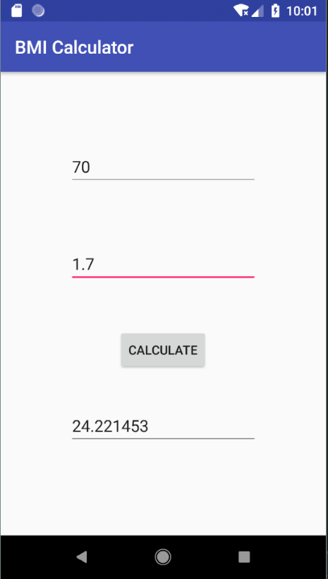

**Application : 7**

AIM :

Design and develop an android application for arithmetic calculator having all possible arithmetic operations.

Objectives

To get familiar with different buttons calling same methods.

Apparatus/Tools/Equipments/Components

Android studio

Procedure

1. In Android Studio, create a new project.

2. Give the name to the Application and choose the project location and minimum android sdk version to marshmallow.

3. Select empty activity for development of android application.

4. Design UI for the application

5. Implement the java code for the application.

6. Open AVD manager and Run virtual device.

7. Run project on virtual device.

MainActivity.java

package com.example.ishank.calculator;

import android.support.v7.app.AppCompatActivity;

import android.os.Bundle;

import android.view.View;

import android.widget.EditText;

public class MainActivity extends AppCompatActivity {

@Override

protected void onCreate(Bundle savedInstanceState) {

super.onCreate(savedInstanceState);

setContentView(R.layout.activity_main);

}

public void calculate(View v){

EditText et,et2,et3;

et=findViewById(R.id.editText);

et2=findViewById(R.id.editText2);

et3=findViewById(R.id.editText3);

int first,second;

float ans;

first=Integer.parseInt(et.getText().toString());

second=Integer.parseInt(et2.getText().toString());

if(v.getId()==R.id.sum)

ans=first+second;

else if(v.getId()==R.id.sub)

ans=first-second;

else if(v.getId()==R.id.mul)

ans=first*second;

else if(v.getId()==R.id.div)

ans=(float)first/second;

else

ans=first%second;

et3.setText(String.valueOf(ans));

}

}

Activity_main.xml

<?xml version="1.0" encoding="utf-8"?>

<android.support.constraint.ConstraintLayout xmlns:android="http://schemas.android.com/apk/res/android"

xmlns:app="http://schemas.android.com/apk/res-auto"

xmlns:tools="http://schemas.android.com/tools"

android:layout_width="match_parent"

android:layout_height="match_parent"

tools:context=".MainActivity">

<EditText

android:id="@+id/editText"

android:layout_width="wrap_content"

android:layout_height="wrap_content"

android:layout_marginBottom="16dp"

android:layout_marginEnd="16dp"

android:layout_marginStart="16dp"

android:layout_marginTop="16dp"

android:ems="10"

android:hint="Enter first number"

android:inputType="textPersonName"

app:layout_constraintBottom_toBottomOf="parent"

app:layout_constraintEnd_toEndOf="parent"

app:layout_constraintHorizontal_bias="0.437"

app:layout_constraintStart_toStartOf="parent"

app:layout_constraintTop_toTopOf="parent"

app:layout_constraintVertical_bias="0.048" />

<EditText

android:id="@+id/editText2"

android:layout_width="wrap_content"

android:layout_height="wrap_content"

android:layout_marginBottom="16dp"

android:layout_marginEnd="16dp"

android:layout_marginStart="16dp"

android:layout_marginTop="16dp"

android:ems="10"

android:hint="Enter second number"

android:inputType="textPersonName"

app:layout_constraintBottom_toBottomOf="parent"

app:layout_constraintEnd_toEndOf="parent"

app:layout_constraintHorizontal_bias="0.437"

app:layout_constraintStart_toStartOf="parent"

app:layout_constraintTop_toBottomOf="@+id/editText"

app:layout_constraintVertical_bias="0.074" />

<Button

android:id="@+id/sum"

android:layout_width="wrap_content"

android:layout_height="wrap_content"

android:layout_marginStart="64dp"

android:layout_marginTop="276dp"

android:onClick="calculate"

android:text="+"

android:textStyle="bold"

app:layout_constraintStart_toStartOf="parent"

app:layout_constraintTop_toTopOf="parent" />

<Button

android:id="@+id/sub"

android:layout_width="wrap_content"

android:layout_height="wrap_content"

android:layout_marginEnd="56dp"

android:layout_marginStart="16dp"

android:onClick="calculate"

android:text="-"

android:textStyle="bold"

app:layout_constraintBaseline_toBaselineOf="@+id/sum"

app:layout_constraintEnd_toEndOf="parent"

app:layout_constraintHorizontal_bias="0.833"

app:layout_constraintStart_toEndOf="@+id/sum" />

<Button

android:id="@+id/mul"

android:layout_width="wrap_content"

android:layout_height="wrap_content"

android:layout_marginBottom="16dp"

android:layout_marginStart="64dp"

android:layout_marginTop="40dp"

android:onClick="calculate"

android:text="*"

android:textStyle="bold"

app:layout_constraintBottom_toBottomOf="parent"

app:layout_constraintStart_toStartOf="parent"

app:layout_constraintTop_toBottomOf="@+id/sum"

app:layout_constraintVertical_bias="0.0" />

<Button

android:id="@+id/div"

android:layout_width="wrap_content"

android:layout_height="wrap_content"

android:layout_marginEnd="68dp"

android:layout_marginStart="16dp"

android:onClick="calculate"

android:text="/"

android:textStyle="bold"

app:layout_constraintBaseline_toBaselineOf="@+id/mul"

app:layout_constraintEnd_toEndOf="parent"

app:layout_constraintHorizontal_bias="1.0"

app:layout_constraintStart_toEndOf="@+id/mul" />

<EditText

android:id="@+id/editText3"

android:layout_width="wrap_content"

android:layout_height="wrap_content"

android:layout_marginBottom="16dp"

android:layout_marginEnd="16dp"

android:layout_marginStart="16dp"

android:layout_marginTop="36dp"

android:ems="10"

android:hint="Result"

android:inputType="textPersonName"

app:layout_constraintBottom_toBottomOf="parent"

app:layout_constraintEnd_toEndOf="parent"

app:layout_constraintHorizontal_bias="0.437"

app:layout_constraintStart_toStartOf="parent"

app:layout_constraintTop_toBottomOf="@+id/editText2"

app:layout_constraintVertical_bias="0.0" />

<Button

android:id="@+id/mod"

android:layout_width="wrap_content"

android:layout_height="wrap_content"

android:layout_marginBottom="16dp"

android:layout_marginEnd="16dp"

android:layout_marginStart="16dp"

android:layout_marginTop="16dp"

android:onClick="calculate"

android:text="%"

android:textStyle="bold"

app:layout_constraintBottom_toBottomOf="parent"

app:layout_constraintEnd_toEndOf="parent"

app:layout_constraintStart_toStartOf="parent"

app:layout_constraintTop_toTopOf="parent"

app:layout_constraintVertical_bias="0.96" />

</android.support.constraint.ConstraintLayout>

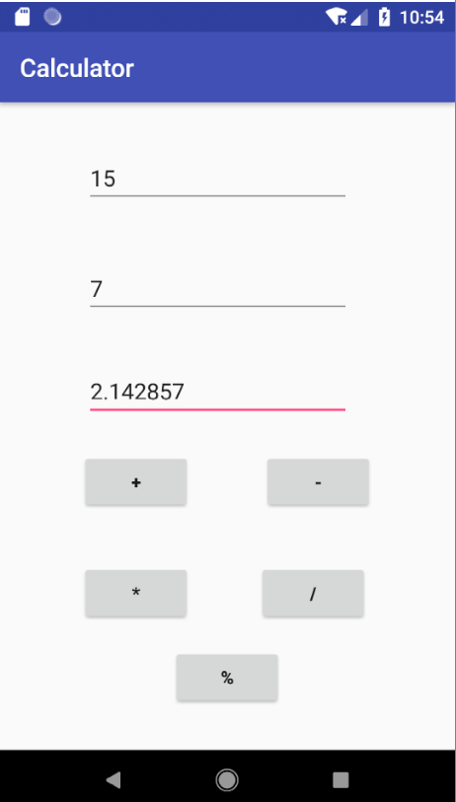

**Application : 8**

AIM :

Design and develop android application for music player.

Objectives

To get familiar with services in android.

Apparatus/Tools/Equipments/Components

Android studio

Procedure

1. In Android Studio, create a new project.

2. Give the name to the Application and choose the project location and minimum android sdk version to marshmallow.

3. Select empty activity for development of android application.

4. Design UI for the application

5. Implement the java code for the application.

6. Implement the MusicService.java file.

7. Open AVD manager and Run virtual device.

8. Run project on virtual device.

MainActivity.java

package com.example.ishank.musicplayer;

import android.support.v7.app.AppCompatActivity;

import android.os.Bundle;

import android.view.View;

import android.content.Intent;

public class MainActivity extends AppCompatActivity {

@Override

protected void onCreate(Bundle savedInstanceState) {

super.onCreate(savedInstanceState);

setContentView(R.layout.activity_main);

}

public void startMyService(View v){

Intent start=new Intent(this,MyMusic.class);

startService(start);

}

public void stopMyService(View v){

Intent stop=new Intent(this,MyMusic.class);

stopService(stop);

}

}

Activity_main.xml

<?xml version="1.0" encoding="utf-8"?>

<android.support.constraint.ConstraintLayout xmlns:android="http://schemas.android.com/apk/res/android"

xmlns:app="http://schemas.android.com/apk/res-auto"

xmlns:tools="http://schemas.android.com/tools"

android:layout_width="match_parent"

android:layout_height="match_parent"

tools:context=".MainActivity">

<Button

android:id="@+id/button3"

android:layout_width="wrap_content"

android:layout_height="wrap_content"

android:layout_marginBottom="16dp"

android:layout_marginEnd="16dp"

android:layout_marginStart="16dp"

android:layout_marginTop="16dp"

android:onClick="startMyService"

android:text="Play"

app:layout_constraintBottom_toBottomOf="parent"

app:layout_constraintEnd_toEndOf="parent"

app:layout_constraintHorizontal_bias="0.45"

app:layout_constraintStart_toStartOf="parent"

app:layout_constraintTop_toTopOf="parent"

app:layout_constraintVertical_bias="0.169" />

<Button

android:id="@+id/button2"

android:layout_width="wrap_content"

android:layout_height="wrap_content"

android:layout_marginBottom="168dp"

android:layout_marginEnd="16dp"

android:layout_marginStart="16dp"

android:layout_marginTop="16dp"

android:onClick="stopMyService"

android:text="Pause"

app:layout_constraintBottom_toBottomOf="parent"

app:layout_constraintEnd_toEndOf="parent"

app:layout_constraintHorizontal_bias="0.45"

app:layout_constraintStart_toStartOf="parent"

app:layout_constraintTop_toBottomOf="@+id/button"

app:layout_constraintVertical_bias="0.442" />

</android.support.constraint.ConstraintLayout>

MyMusic.java

package com.example.ishank.musicplayer;

import android.app.Service;

import android.content.Intent;

import android.media.MediaPlayer;

import android.os.IBinder;

public class MyMusic extends Service {

public MyMusic() {

}

MediaPlayer player;

@Override

public IBinder onBind(Intent intent) {

// TODO: Return the communication channel to the service.

throw new UnsupportedOperationException("Not yet implemented");

}

@Override

public void onCreate() {

super.onCreate();

player=MediaPlayer.create(this,R.raw.venom);

}

@Override

public int onStartCommand(Intent intent, int flags, int startId) {

player.start();

return super.onStartCommand(intent, flags, startId);

}

@Override

public void onDestroy() {

super.onDestroy();

player.stop();

}

}

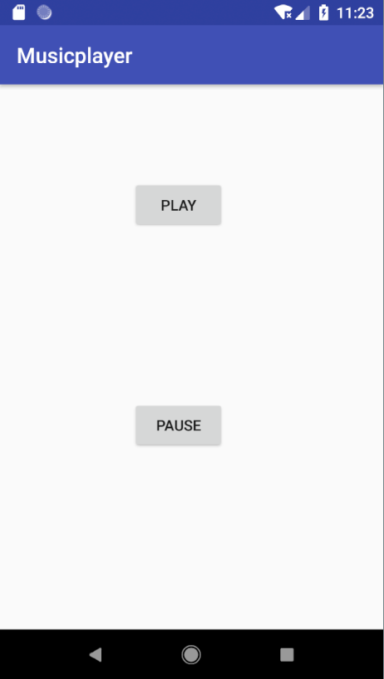

**Application : 9**

AIM :

Design and develop an android application to send email.

Objectives

To get familiar use of intent in android.

Apparatus/Tools/Equipments/Components

Android studio

Procedure

1. In Android Studio, create a new project.

2. Give the name to the Application and choose the project location and minimum android sdk version to marshmallow.

3. Select empty activity for development of android application.

4. Design UI for the application

5. Implement the java code for the application.

6. Open AVD manager and Run virtual device.

7. Run project on virtual device.

MainActivity.java

package com.example.ishank.email;

import android.content.Intent;

import android.net.Uri;

import android.support.v7.app.AppCompatActivity;

import android.os.Bundle;

import android.view.View;

import android.widget.Button;

import android.widget.EditText;

public class MainActivity extends AppCompatActivity {

@Override

protected void onCreate(Bundle savedInstanceState) {

super.onCreate(savedInstanceState);

setContentView(R.layout.activity_main);

Button b=findViewById(R.id.button);

b.setOnClickListener(new View.OnClickListener(){

@Override

public void onClick(View view) {

Intent in=new Intent(Intent.ACTION_SEND);

EditText et,et2,et3;

et=findViewById(R.id.editText);

et2=findViewById(R.id.editText2);

et3=findViewById(R.id.editText3);

String to,sub,body;

to=et.getText().toString();

sub=et2.getText().toString();

body=et3.getText().toString();

in.setData(Uri.parse("www.gmail.com"));

in.setType("text/plain");

in.putExtra(Intent.EXTRA_EMAIL,to);

in.putExtra(Intent.EXTRA_SUBJECT,sub);

in.putExtra(Intent.EXTRA_TEXT,body);

startActivity(Intent.createChooser(in,"email send"));

}

});

}

}

Activity_main.xml

<?xml version="1.0" encoding="utf-8"?>

<android.support.constraint.ConstraintLayout xmlns:android="http://schemas.android.com/apk/res/android"

xmlns:app="http://schemas.android.com/apk/res-auto"

xmlns:tools="http://schemas.android.com/tools"

android:layout_width="match_parent"

android:layout_height="match_parent"

tools:context=".MainActivity">

<EditText

android:id="@+id/editText"

android:layout_width="231dp"

android:layout_height="wrap_content"

android:layout_marginEnd="16dp"

android:layout_marginStart="16dp"

android:ems="10"

android:inputType="textPersonName"

app:layout_constraintBaseline_toBaselineOf="@+id/textView"

app:layout_constraintEnd_toEndOf="parent"

app:layout_constraintHorizontal_bias="0.887"

app:layout_constraintStart_toStartOf="parent" />

<TextView

android:id="@+id/textView"

android:layout_width="69dp"

android:layout_height="36dp"

android:layout_marginBottom="16dp"

android:layout_marginEnd="16dp"

android:layout_marginStart="16dp"

android:layout_marginTop="16dp"

android:text="TO:"

android:textAlignment="center"

android:textStyle="bold"

app:layout_constraintBottom_toBottomOf="parent"

app:layout_constraintEnd_toStartOf="@+id/editText"

app:layout_constraintHorizontal_bias="0.695"

app:layout_constraintStart_toStartOf="parent"

app:layout_constraintTop_toTopOf="parent"

app:layout_constraintVertical_bias="0.069" />

<TextView

android:id="@+id/textView2"

android:layout_width="67dp"

android:layout_height="36dp"

android:layout_marginBottom="16dp"

android:layout_marginEnd="16dp"

android:layout_marginStart="16dp"

android:layout_marginTop="16dp"

android:text="Subject:"

android:textAlignment="viewStart"

android:textSize="18sp"

android:textStyle="bold"

app:layout_constraintBottom_toBottomOf="parent"

app:layout_constraintEnd_toEndOf="parent"

app:layout_constraintHorizontal_bias="0.063"

app:layout_constraintStart_toStartOf="parent"

app:layout_constraintTop_toBottomOf="@+id/textView"

app:layout_constraintVertical_bias="0.063" />

<EditText

android:id="@+id/editText2"

android:layout_width="228dp"

android:layout_height="wrap_content"

android:layout_marginEnd="16dp"

android:layout_marginStart="16dp"

android:ems="10"

android:inputType="textPersonName"

app:layout_constraintBaseline_toBaselineOf="@+id/textView2"

app:layout_constraintEnd_toEndOf="parent"

app:layout_constraintHorizontal_bias="0.304"

app:layout_constraintStart_toEndOf="@+id/textView2" />

<EditText

android:id="@+id/editText3"

android:layout_width="317dp"

android:layout_height="204dp"

android:layout_marginEnd="16dp"

android:layout_marginStart="16dp"

android:layout_marginTop="200dp"

android:ems="10"

android:hint="BODY"

android:inputType="textPersonName"

app:layout_constraintEnd_toEndOf="parent"

app:layout_constraintHorizontal_bias="0.514"

app:layout_constraintStart_toStartOf="parent"

app:layout_constraintTop_toTopOf="parent" />

<Button

android:id="@+id/button"

android:layout_width="wrap_content"

android:layout_height="wrap_content"

android:layout_marginBottom="16dp"

android:layout_marginEnd="16dp"

android:layout_marginStart="16dp"

android:layout_marginTop="16dp"

android:text="SEND"

android:textStyle="bold"

app:layout_constraintBottom_toBottomOf="parent"

app:layout_constraintEnd_toEndOf="parent"

app:layout_constraintStart_toStartOf="parent"

app:layout_constraintTop_toBottomOf="@+id/editText3" />

</android.support.constraint.ConstraintLayout>

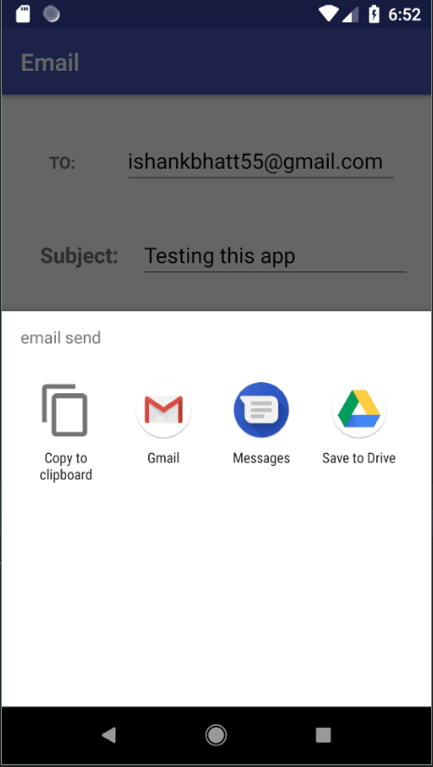

**Application : 13**

AIM :

Create an android application to demonstrate rating bar.

Objectives

To get familiar use of rating bar in android.

Apparatus/Tools/Equipments/Components

Android studio

Procedure

1. In Android Studio, create a new project.

2. Give the name to the Application and choose the project location and minimum android sdk version to marshmallow.

3. Select empty activity for development of android application.

4. Design UI for the application

5. Implement the java code for the application.

6. Open AVD manager and Run virtual device.

7. Run project on virtual device.

MainActivity.java

package com.example.ishank.ratingbar;

import android.support.v7.app.AppCompatActivity;

import android.os.Bundle;

import android.view.View;

import android.widget.RatingBar;

import android.widget.Toast;

public class MainActivity extends AppCompatActivity {

@Override

protected void onCreate(Bundle savedInstanceState) {

super.onCreate(savedInstanceState);

setContentView(R.layout.activity_main);

}

public void rating(View v){

RatingBar rating=findViewById(R.id.ratingBar);

/*rating.setOnRatingBarChangeListener(new RatingBar.OnRatingBarChangeListener() {

@Override

public void onRatingChanged(RatingBar ratingBar, float v, boolean b) {

tv.setText(String.valueOf(v));

}

});*/

Toast.makeText(this,String.valueOf(rating.getRating()),Toast.LENGTH_LONG).show();

}

}

Activity_main.xml

<?xml version="1.0" encoding="utf-8"?>

<android.support.constraint.ConstraintLayout xmlns:android="http://schemas.android.com/apk/res/android"

xmlns:app="http://schemas.android.com/apk/res-auto"

xmlns:tools="http://schemas.android.com/tools"

android:layout_width="match_parent"

android:layout_height="match_parent"

tools:context=".MainActivity">

<RatingBar

android:id="@+id/ratingBar"

android:layout_width="wrap_content"

android:layout_height="59dp"

android:layout_marginBottom="16dp"

android:layout_marginEnd="16dp"

android:layout_marginStart="16dp"

android:layout_marginTop="16dp"

android:numStars="5"

android:rating="5"

android:stepSize="1"

app:layout_constraintBottom_toBottomOf="parent"

app:layout_constraintEnd_toEndOf="parent"

app:layout_constraintStart_toStartOf="parent"

app:layout_constraintTop_toTopOf="parent"

app:layout_constraintVertical_bias="0.252" />

<TextView

android:id="@+id/textView"

android:layout_width="216dp"

android:layout_height="48dp"

android:layout_marginBottom="16dp"

android:layout_marginEnd="16dp"

android:layout_marginStart="16dp"

android:layout_marginTop="16dp"

android:text="Rate this App"

android:textAlignment="center"

android:textSize="18sp"

android:textStyle="bold"

app:layout_constraintBottom_toBottomOf="parent"

app:layout_constraintEnd_toEndOf="parent"

app:layout_constraintStart_toStartOf="parent"

app:layout_constraintTop_toTopOf="parent"

app:layout_constraintVertical_bias="0.053" />

<Button

android:id="@+id/button"

android:layout_width="wrap_content"

android:layout_height="wrap_content"

android:layout_marginBottom="16dp"

android:layout_marginEnd="16dp"

android:layout_marginStart="16dp"

android:layout_marginTop="16dp"

android:onClick="rating"

android:text="SUBMIT"

app:layout_constraintBottom_toBottomOf="parent"

app:layout_constraintEnd_toEndOf="parent"

app:layout_constraintStart_toStartOf="parent"

app:layout_constraintTop_toBottomOf="@+id/ratingBar"

app:layout_constraintVertical_bias="0.2" />

</android.support.constraint.ConstraintLayout>

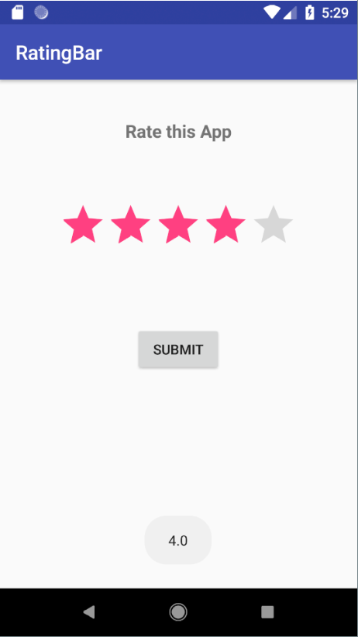

**Application : 20**

AIM :

Design and develop an android application to demonstrate fragment.

Objectives

To get familiar use of rating bar in android.

Apparatus/Tools/Equipments/Components

Android studio

Procedure

1. In Android Studio, create a new project.

2. Give the name to the Application and choose the project location and minimum android sdk version to marshmallow.

3. Select empty activity for development of android application.

4. Design UI for the application.

5. Implement the java code for the application.

6. Add fragment to the project.

7. Open AVD manager and Run virtual device.

8. Run project on virtual device.

MainActivity.java

package com.example.ishank.fragment;

import android.support.v7.app.AppCompatActivity;

import android.os.Bundle;

public class MainActivity extends AppCompatActivity {

@Override

protected void onCreate(Bundle savedInstanceState) {

super.onCreate(savedInstanceState);

setContentView(R.layout.activity_main);

}

}

HeadlineFragment.java

package com.example.ishank.fragment;

import android.os.Bundle;

import android.support.annotation.NonNull;

import android.support.annotation.Nullable;

import android.support.v4.app.Fragment;

import android.view.LayoutInflater;

import android.view.View;

import android.view.ViewGroup;

public class HeadlineFragment extends Fragment {

@Nullable

@Override

public View onCreateView(@NonNull LayoutInflater inflater, @Nullable ViewGroup container, @Nullable Bundle savedInstanceState) {

View view=inflater.inflate(R.layout.headline_fragment_layout,container,false);

return view;

}

}

ArticleFragment.java

package com.example.ishank.fragment;

import android.os.Bundle;

import android.support.annotation.NonNull;

import android.support.annotation.Nullable;

import android.support.v4.app.Fragment;

import android.view.LayoutInflater;

import android.view.View;

import android.view.ViewGroup;

public class ArticleFragment extends Fragment {

@Nullable

@Override

public View onCreateView(@NonNull LayoutInflater inflater, @Nullable ViewGroup container, @Nullable Bundle savedInstanceState) {

return inflater.inflate(R.layout.article_fragment_layout,container,false);

}

}

Activity_main.xml

<?xml version="1.0" encoding="utf-8"?>

<LinearLayout

xmlns:app="http://schemas.android.com/apk/res-auto"

xmlns:tools="http://schemas.android.com/tools"

xmlns:android="http://schemas.android.com/apk/res/android"

android:layout_width="match_parent"

android:layout_height="match_parent"

tools:context=".MainActivity"

android:orientation="vertical"

>

<fragment

android:layout_width="match_parent"

android:layout_height="0dp"

android:id="@+id/headline_fragment"

android:layout_weight="1"

android:name="com.example.ishank.fragment.HeadlineFragment">

</fragment>

<fragment

android:layout_width="match_parent"

android:layout_height="0dp"

android:id="@+id/article_fragment"

android:layout_weight="2"

android:name="com.example.ishank.fragment.ArticleFragment">

</fragment>

</LinearLayout>

Headline_fragment_layout.xml

<?xml version="1.0" encoding="utf-8"?>

<android.support.constraint.ConstraintLayout

xmlns:android="http://schemas.android.com/apk/res/android"

xmlns:app="http://schemas.android.com/apk/res-auto"

xmlns:tools="http://schemas.android.com/tools"

android:layout_width="match_parent"

android:layout_height="match_parent">

<TextView

android:id="@+id/textView"

android:layout_width="wrap_content"

android:layout_height="38dp"

android:layout_marginBottom="32dp"

android:layout_marginEnd="8dp"

android:layout_marginLeft="8dp"

android:layout_marginRight="8dp"

android:layout_marginStart="8dp"

android:layout_marginTop="32dp"

android:text="Headline Fragment"

android:textSize="30sp"

android:textStyle="bold"

app:layout_constraintBottom_toBottomOf="parent"

app:layout_constraintEnd_toEndOf="parent"

app:layout_constraintStart_toStartOf="parent"

app:layout_constraintTop_toTopOf="parent" />

</android.support.constraint.ConstraintLayout>

Article_fragment_layout.xml

<?xml version="1.0" encoding="utf-8"?>

<android.support.constraint.ConstraintLayout

xmlns:android="http://schemas.android.com/apk/res/android"

xmlns:app="http://schemas.android.com/apk/res-auto"

xmlns:tools="http://schemas.android.com/tools"

android:layout_width="match_parent"

android:layout_height="match_parent">

<TextView

android:id="@+id/textView"

android:layout_width="wrap_content"

android:layout_height="wrap_content"

android:layout_marginBottom="32dp"

android:layout_marginEnd="8dp"

android:layout_marginLeft="8dp"

android:layout_marginRight="8dp"

android:layout_marginStart="8dp"

android:layout_marginTop="32dp"

android:text="@string/article_fragment"

android:textAlignment="center"

android:textSize="30sp"

android:textStyle="bold"

app:layout_constraintBottom_toBottomOf="parent"

app:layout_constraintEnd_toEndOf="parent"

app:layout_constraintStart_toStartOf="parent"

app:layout_constraintTop_toTopOf="parent" />

</android.support.constraint.ConstraintLayout>

